# IBM Data Science Professional – Applied Capstone Project

# Recommending Locations for Opening a New Restaurant at Co. Galway in the Republic of Ireland

# I. Introduction

In the modern business environment, spatial analytics plays a critical role in improving business values by elevating location-based insights to business problems. In this study, we focus primarily on analyzing the geospatial data of the Republic of Ireland and recommend a set of locations that could be fitting for starting a restaurant business. For the same, we employ the Foursquare API to retrieve neighborhood information to analyze and group areas that are similar.

# II. Background

The Republic of Ireland has 32 counties and four provinces. Since the businesses are already well-established in the provinces Leinster, Ulster, and Munster, they wanted to expand the company to a county in the Connacht region. For simplification, we chose Co. Galway from Connacht for our study. Co. Galway is ranked 5th in the overall population of Ireland and 1st in the Connacht province. Therefore, setting up the restaurant in Co. Galway will improve the business.

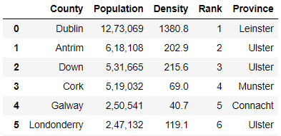

**Figure 1**: Counties of Ireland

# III. Problem Statement

To analyze the neighborhoods of Co. Galway based on the popular venues and recommend a set of locations that suit well for setting up a new restaurant.

# IV. Business Requirements

* The neighbourhood should be a busy area with plenty of foot traffic.
* The region should have enough bars and pubs nearby
* Should have relatively less number of restaurants opened in the same spot

# V. Data Understanding

## a) Datasets Used

* **Dataset 1**: Ireland Counties Dataset | Available @ [list-counties-ireland.csv](https://www.downloadexcelfiles.com/sites/default/files/docs/list-counties-ireland-433j.csv)



**Figure 2**: Ireland Counties Data Sample

* **Dataset 2**: Neighborhoods in Co. Galway

**Since no public datasets are available for the neighborhood or town names in Co**. Galway, we manually created a data frame with 67 neighborhoods. Given below is a snippet of the data frame.

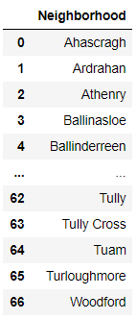

**Figure 3**: List of Neighborhoods in Co. Galway, Ireland

## b) Data Pre-processing and Visualization

Initially, for improved understanding, we plot the 32 counties of Ireland on to a folium map using their latitude and longitude coordinates. Since the dataset has no spatial data, we make use of geopy python library to fetch the latitude and longitude coordinates using the name of the counties.

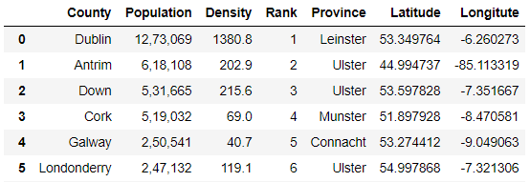

**Figure 4**: Counties of Ireland with Latitude & Longitude coordinates

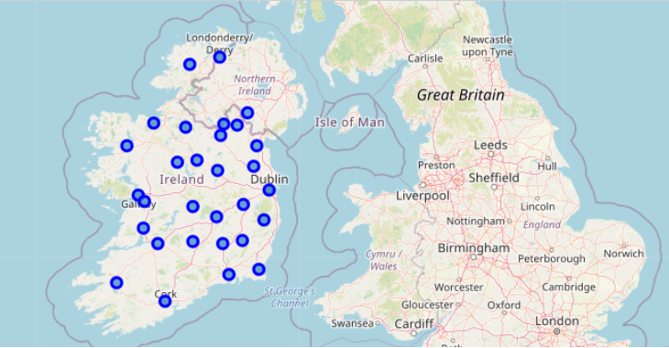

**Figure 5**: Counties of Ireland plotted on world map

**Plotting Co. Galway**

The primary objective of the project is to identify locations or neighborhoods in Co. Galway that might interest the stakeholders in starting a restaurant. Therefore, we filter only the coordinated of Co. Galway and plot it onto a folium map.



**Figure 6**: Fetching only the coordinates of Co. Galway

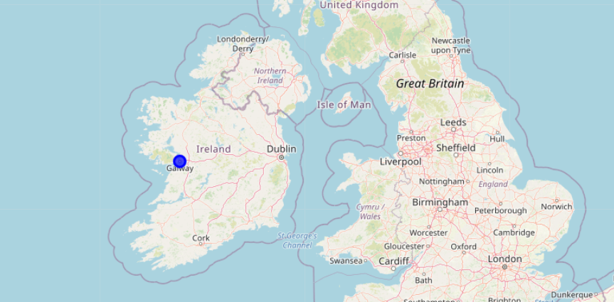

**Figure 7**: Location of Co. Galway in the Republic of Ireland

**Fetching Neighborhoods in Co. Galway**  
  
As the next step, we fetch the latitude and longitude coordinates of the cities in Co. Galway using the geopy library. It is to be noted that the neighborhoods or towns in Co. Galway is scraped manually from the web. Finally, we plot the regions onto a world map.

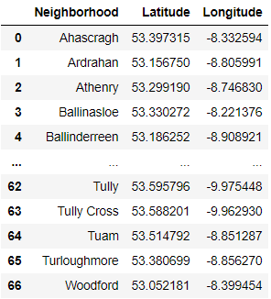

**Figure 8**: Latitude & Longitude coordinates of Neighborhoods of Co. Galway

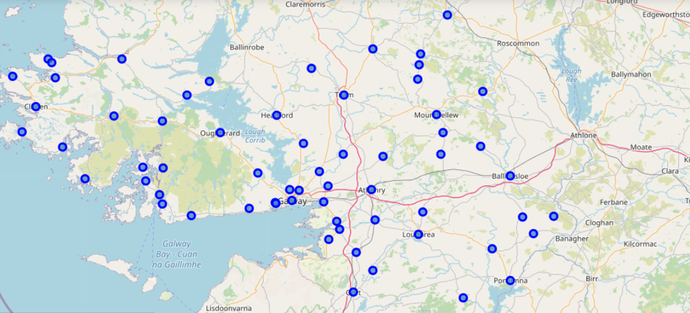

**Figure 9**: Neighborhoods of Co. Galway

**Fetching Venues using Foursquare API**  
  
Using Foursquare API, we identify the venues at each of the neighborhood in Co. Galway. Further, we create data frame with information on the venues.

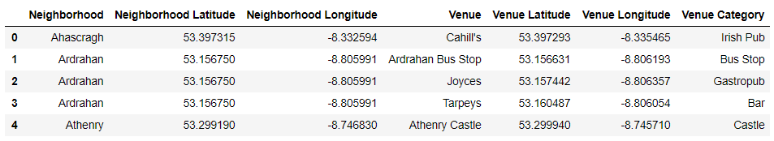

**Figure 10**: Venues fetched using Foursquare API

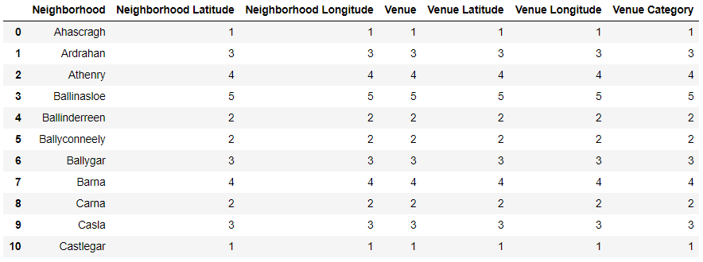

**Figure 11**: Venue Info grouped by Neighborhood

**Assumptions:**

* Venue Category (**Figure 11**) is directly proportional to Foot traffic
* Positive Venues Categories: Bars and Pubs
* Negative Venues Categories: Restaurant, Fast Food Restaurant, Seafood Restaurant, Vegan Restaurant, Middle Eastern Restaurant, Chinese Restaurant, Mexican Restaurant, Indian Restaurant, Asian Restaurant, French Restaurant, Japanese Restaurant and Italian Restaurant

In the following sections, we will cluster neighborhoods based on the count of Venue Category (foot traffic), number of positive venues like bar and pubs, also on the number of negative venues like other restaurants.